**Notes of Study on Dec 2, 2022 (Fri)**

Based on lecture notes of Stanford cs231n

Module 1: Neural Networks

L1/L2 distances, hyperparameter search, cross-validation

[Image Classification: Data-driven Approach, k-Nearest Neighbor, train/val/test splits](https://cs231n.github.io/classification/)

And a related video:

**Lecture 2 | Image Classification**

<https://www.youtube.com/watch?v=OoUX-nOEjG0>

Training set and test set

* Training set being split in two: a slightly smaller training set called a validation set, and the set of data to train the model.
* Test set: to test the performance of the predictor in the end only a single time.
* Cross validation: a multi-folder way to split the original training set. For example:

In 5-fold cross-validation, we would split the training data into 5 equal folds, use 4 of them for training, and 1 for validation. We would then iterate over which fold is the validation fold, evaluate the performance, and finally average the performance across the different folds.

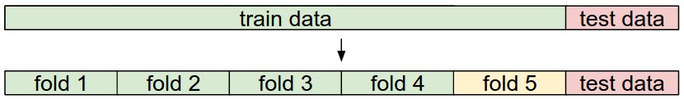

Where one fold (e.g. fold 5 here in yellow) is denoted as the Validation fold and is used to tune the hyperparameters.

Hint: use np.array_split() to split the training data into n_folds folds.

L1 norm (L1 distance):

e.g.

L2 norm (L2 distance):

$$d_{2}(I_{1},I_{2})=\sqrt{\sum_{p}{{\left(I_{1}^{p}-I_{2}^{p}\right)}^{2}}}$$

Next study:

[Linear classification: Support Vector Machine, Softmax](https://cs231n.github.io/linear-classify/)

parameteric approach, bias trick, hinge loss, cross-entropy loss, L2 regularization, web demo

And,

[**https://www.youtube.com/watch?v=h7iBpEHGVNc**](https://www.youtube.com/watch?v=h7iBpEHGVNc)